National University of Computer and Emerging Sciences



Lab Exercise 03

For

Object Oriented Programming Lab

|  |  |
| --- | --- |
| Course Instructor(s) | Dr. Danish |
| Lab Instructor(s) | Mr. Mughees Ismail |
| Semester | Spring 2020 |

**FAST School of Computing**

# Instructions:

1. Make a word document with the naming convention “SECTION_ LAB#_ROLLNO” and put all your source code and snapshots of its output in it. Make sure your word file is formatted properly.
2. Plagiarism is strictly prohibited.
3. Do not discuss solutions with one another.

# Useful links

|  |
| --- |
| **Question#1** |

Write a program in C to count the digits of a given number using recursion.

|  |
| --- |
| **Question#2** |

Write a function to recursively see if a number is prime or not, the function should return true when the base case has met, false otherwise.

|  |
| --- |
| **Question#3** |

With the help of two functions, print out all the prime number from that number down to 0. For example if 50 is passed to the function the output should be:

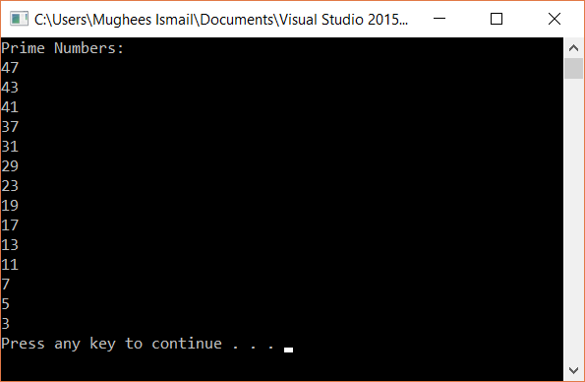

|  |
| --- |
| **Question#4** |

Write a program in C to find the Factorial of a number using recursion.